DISTRICT DISASTER MANGEMENT PLAN GOPALGANJ
inception report
Contents
Disclaimer 3
1. Executive Summary and Introduction 4
2. Conceptual Framework of DDMP 5
a. Futuristic Plan with Historical Perspective 5
b. Understanding about DDMP (Multi-Hazard Focus) 6
c. Identifying current and potential risks 10
d. Action Oriented Plan 12
3. Scope of the Project 12
a. Approach for Comprehensive Plan 12
b. Consideration for lower administrative units below district – Block & Panchayat level interventions 12
c. Mainstreaming DRR & CCA to be taken into consideration 13
d. Value addition by agencies 13
4. Districts’ Profile 13
a. Multi-hazard focus - including vulnerabilities in terms of socio-economic details and also the capacities existing in the districts 13
b. DisasterRisk and Vulnerability Profile 14
5. Approach, Methodology and Activities 15
a. Data Sources – Primary & Secondary (including relevant maps) 15
b. Stakeholders’ involvement (including IDRN) 16
6. DDMP Preparation Planning & and Reporting Mechanism 17
a. Ensuring involvement and ownership of DDMAs 17
7. Timeline and Delivery Schedule (Table) 17
8. Monitoring and Evaluation System 19
9. Project Team 20
a. Team Leaders and other Team Members – CV (Qualifications and Experience), Roles and Responsibilities etc. 20

Disclaimer

The contents of this report are prepared by Caritas India for the exclusive purpose of presenting to Bihar State Disaster Management Authority (BSDMA)/ Districts under the provisions of the contract signed between the two. The contents of this report should not be published or used by anyone without prior written permission of BSDMA or Caritas India. All content is based on the information collected by Caritas India through primary and secondary sources including BSDMA and respective district website. While Caritas India has taken due care in collecting data only from verified sources, Caritas India is not liable for any misrepresented fact or error in such data.
We have made specific efforts to verify the accuracy and authenticity of the information gathered where it was felt necessary.

Executive Summary and Introduction
It is proposed to accelerate the District Disaster Management Plans in Bihar more Inclusive so as to make Bihar safer. Here, inclusive word is considered as “to collect voices of the vulnerable groups, i.e. poorest of poor, women, children, physically challenged, old aged, Dalits and minorities. Their needs should be fulfilled during emergencies. So, it is vital that the needs of the vulnerable groups should be included in the DDMPs. The focus of the work is on making District Disaster Management Plans directly focused on the risks faced by the poor and excluded communities, and at the same time make poor and excluded vulnerable communities have more direct say in District Disaster Management Plans. The proposal builds on ISDR call for more local action within HFA and UNDP push for building local DRR capacity with CSO-GO joint action, where Flagship schemes for advocacy are also incorporated.
The District Disaster Management Plans (DDMPs) are not looked at by Civil Society in a systematic way on its own or with the authorities. More focus on poor in DDMPs is missing, the DDMPs are more government exercise and in most cases civil societies are left out. The National Disaster Management Authorities has not reviewed DDMPs that are made by the districts with help from National Institute of Disaster Management guidelines and UNDP support.
As per Disaster Management Act 2005, there shall be a plan for disaster management for every district of the State. The District Plan shall be prepared by the District Authority, after consultation with the local authorities and having regard to the National Plan and the State Plan, to be approved by the State Authority. The District Plan shall include-

  - the areas in the district vulnerable to different forms of disasters;
  - the measures to be taken, for prevention and mitigation of disaster, by the Departments of the Government at the district level and local authorities in the district;
  - the capacity-building and preparedness measures required to be taken by the Departments of the Government at the district level and the local authorities in the district to respond to any threatening disaster situation or disaster;
  - the response plans and procedures, in the event of a disaster
On the basis of secondary data available the risk assessment of the districts has been done. These past data shows that there are chances of multi hazard threats in Buxar.
The approach towards the entire exercise would include secondary data collection, stakeholder mapping, survey tool development including development of questionnaire, checklist and draft template, training of local survey teams, primary data collection and use of GIS for hazard mapping, resource mapping and vulnerability mapping. District level consultation will be organised in each proposed project district during the project to revise the outline to make the DDMP Inclusive. This will be mainly with District, Disaster Management Authority (DDMA) and other line departments, PRIs, municipalities/ municipal corporations, grassroots organisations/CBOs and communities. This will be facilitated by Caritas India along with DDMA of the respective districts. The outputs will be the district level Advisory Committee of each district and detail timeline from district authorities to adopt the process and methodologies of Multi hazard DDMP.

Conceptual Framework of DDMP

Futuristic Plan with Historical Perspective
It is proposed to accelerate the District Disaster Management Plans in Bihar more Inclusive so as to make Bihar safer. Here, inclusive word is considered as “to collect voices of the vulnerable groups, i.e. poorest of poor, women, children, physically challenged, old aged, Dalits and minorities. Their needs should be fulfilled during emergencies. So, it is vital that the needs of the vulnerable groups should be included in the DDMPs. The focus of the work is on making District Disaster Management Plans directly focused on the risks faced by the poor and excluded communities, and at the same time make poor and excluded vulnerable communities have more direct say in District Disaster Management Plans. The proposal builds on ISDR call for more local action within HFA and UNDP push for building local DRR capacity with CSO-GO joint action, where Flagship schemes for advocacy are also incorporated.

The District Disaster Management Plans (DDMPs) are not looked at by Civil Society in a systematic way on its own or with the authorities. More focus on poor in DDMPs is missing, the DDMPs are more government exercise and in most cases civil societies are left out. The National Disaster Management Authorities has not reviewed DDMPs that are made by the districts with help from National Institute of Disaster Management guidelines and UNDP support.

Disaster Management is still with government sector (largely) and government functionaries at the cutting edge level are not at all involved in building Community Managed Disaster Risk Reduction (CMDRR) ex-ante (and also do not have enough skills to do that). Hence, dependence of CMDRR is very high on the NGO and civil society. Ex-ante resource availability with NGOs, especially in the less frequency and high intensity zone is not adequate to keep pre disaster interest alive. The experience after all the past disasters and calamities is that the most vulnerable and marginalized Dalit communities and their women, children and aged were the people who were again the most affected and yet the discriminated in every aspect of the relief works: in identifying them as victims in the disaster, in evaluating their losses, and including them in the planning, monitoring and implementation of programmes for their future rehabilitation. Vulnerable groups have thier rights during various stages of disasters. And thus, right based approach during response and mitigation is important and therefore, right based disaster management planning is key and vital to make it inclusive in its real manner.

Understanding about DDMP (Multi-Hazard Focus)
As per Disaster Management Act 2005, there shall be a plan for disaster management for every district of the State. The District Plan shall be prepared by the District Authority, after consultation with the local authorities and having regard to the National Plan and the State Plan, to be approved by the State Authority. The District Plan shall include-

    - the areas in the district vulnerable to different forms of disasters;
    - the measures to be taken, for prevention and mitigation of disaster, by the Departments of the Government at the district level and local authorities in the district;
    - the capacity-building and preparedness measures required to be taken by the Departments of the Government at the district level and the local authorities in the district to respond to any threatening disaster situation or disaster;
    - the response plans and procedures, in the event of a disaster, providing for-
      - allocation of responsibilities to the Departments of the Government
At the district level and the local authorities in the district;
      - prompt response to disaster and relief thereof;
      - procurement of essential resources;
      - establishment of communication links; and
      - the dissemination of information to the public;
      - Such other matters as may be required by the State Authority.
Bihar is affected by various disasters viz. floods, earthquakes, cyclone, heat wave and cold wave.
Table showing Decadal Multi-Disasternumberof deaths (www.ncrb.nic.in)
Year | ColdWave | Cyclone | Earthquake | Flood | HeatWave | Landslide
2001 | 27 | 14 | 0 | 36 | 47 | 6
2002 | 55 | 4 | 2 | 126 | 22 | 1
2003 | 176 | 8 | 1 | 63 | 70 | 11
2004 | 72 | 9 | 0 | 204 | 32 | 10
2005 | 27 | 11 | 1 | 26 | 68 | 8
2006 | 81 | 4 | 3 | 16 | 52 | 2
2007 | 97 | 14 | 5 | 477 | 58 | 18
2008 | 103 | 4 | 0 | 408 | 28 | 0
2009 | 98 | 0 | 1 | 99 | 46 | 7
2010 | 156 | 26 | 0 | 94 | 95 | 9
2011 | 174 | 22 | 6 | 186 | 86 | 15

History ofFlood in Bihar
Bihar is India’s most flood-prone State, with 76 percent of the population, in the north Bihar living under the recurring threat of flood devastation. About 68800 sq Km. out of total geographical area of 94160 sq Km. comprising 73.06 percent is flood affected.
The plains of Bihar, adjoining Nepal, are drained by a number of rivers that have their catchmentsinthesteep and geologicallynascentHimalayas.Kosi,Gandak, BurhiGandak, Bagmati,KamlaBalan,MahanandaandAdhwaraGroupofriversoriginatesinNepal,carry high dischargeandvery highsedimentloadanddropsitdownintheplainsofBihar.About65%of catchmentsareaoftheseriversfallsinNepal/Tibetandonly35%ofcatchmentsarealiesin Bihar.Intheyears1978,1987,1998,2004and2007Bihar witnessedhighmagnitudesofflood. Thetotalareaaffectedby floodshasalsoincreasedduring theseyears.Floodof2004demonstratestheseverityoffloodproblemwhenavastareaof23490Sq Km. was badlyaffected bythefloods ofBagmati, Kamla&Adhwaragroups of riverscausing lossof about 800 human lives, even whenGanga,the masterdrain was flowinglow.
Table:FloodDamageduring 2001 to 2011
Yea  r | Area  affec ted  in  (m. ha.) | Popul  ationaffect ed in (milli on) | Damageto  crops |  | Damageto  houses |  | Cattle  lost  Nos. | Human  life lost  Nos. | Damag  eto Public Utilities in Rs. crore | Total  damages  Crops, houses & public utilities in Rs. crore
 |  |  | Area  (m. ha.) | Value  (Rs. crore) | Nos. | Value in  Rs. crore
2001 | 1.195 | 9.091 | 0.650 | 267.218 | 222008 | 173.584 | 565 | 231 | 183.538 | 624.340
2002 | 1.969 | 16.018 | 0.941 | 511.495 | 41914 | 526.215 | 1450 | 489 | 408.922 | 1446.632
2003 | 1.508 | 8.798 | 0.610 | 62.660 | 45262 | 20.320 | 106 | 251 | 1035.160 | 1118.140
2004 | 2.700 | 29.985 | 1.399 | 522.056 | 929773 | 758.095 | 3272 | 885 | 1030.496 | 2310.647
2005 | 0.460 | 2.639 | 0.135 | 11.640 | 5538 | 3.828 | 4 | 58 | 3050 | 18.518
2006 | 0.182 | 1.089 | 0.086 | 7.060 | 18637 | 12.260 | 31 | 36 | 84.562 | 103.882
2007 | 1.880 | 2.780 | 1.060 | 768.378 | 784328 | 831.445 | 2423 | 1287 | 642.415 | 2242.239
2008 | 0.882 | 6.212 | 0.367 | 34.196 | 297916 | 84.514 | 878 | 252 | 97.710 | 216.420
2009 | 1.105 | 2.338 | 0.040 | 21.830 | 7674 | 5.282 | 2 | 97 | 5.301 | 32.413
2010 | 0.199 | 1.075 | 0.010 | 3.119 | 15170 | 7.049 | 0 | 100 | 1.592 | 11.760
2011 | 0.000 | 0.581 | 0.163 | 59.870 | 34906 | 17792 | 39 | 143 | 25.786 | 103.448

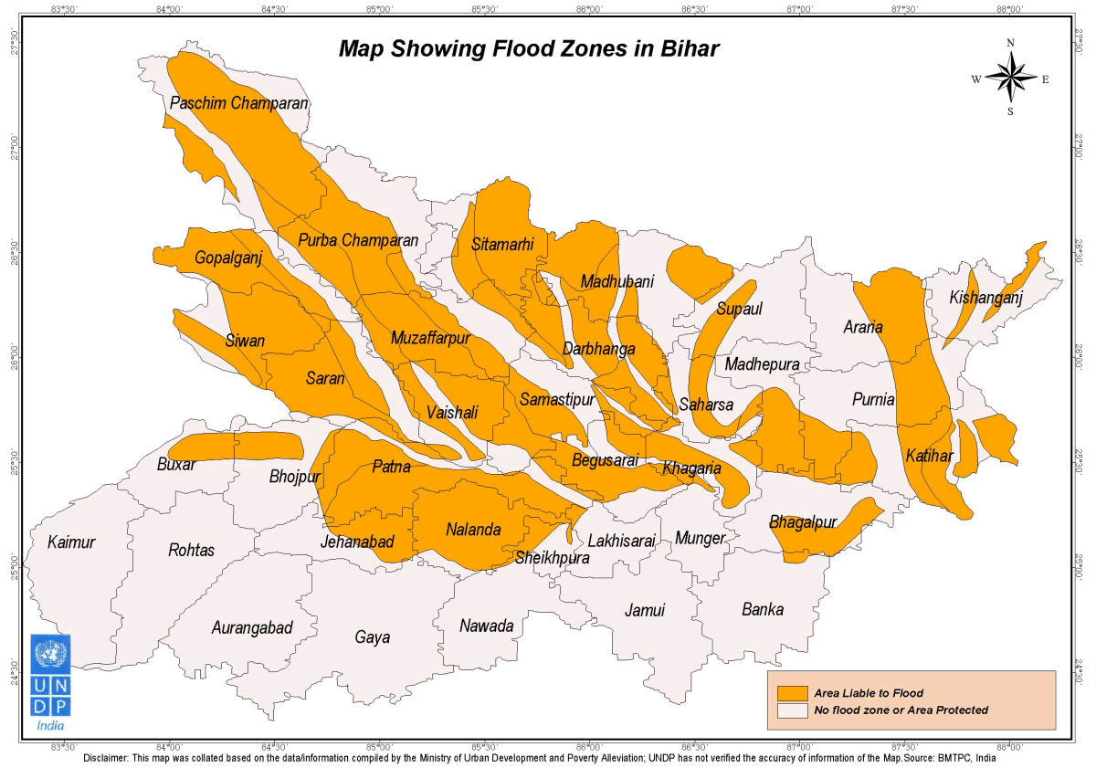

Earthquake:-
AccordingtoGlobalSeismic HazardAssessmentProgram(GSHAP) data,the stateofBihar lies ina regionwithmoderate tolowtohighseismic hazard. As per the 2002BureauofIndian Standards(BIS)map,thisstatealsofallsinZonesIII,IV& V.Historically,thisregionhas experienced earthquakein theM5.0-7.0 range.

EarthquakeHistory of Bihar
The stateofBiharliesintheGangeticPlain.Thisisa fore-deep,a downwarpoftheHimalayan foreland,ofvariabledepth,convertedintoflatplainsby long-vigoroussedimentation.Thisis knownasageosynclineandtheGangeticPlainistheIndo-GangeticGeosyncline.Thishas shownconsiderableamountsofflexure anddislocationatthenorthernendandisboundedonthe northby theHimalayanFrontalThrust.TheflooroftheGangetictrough(ifseewithoutallthe sediments) isnotaneven plain (5),butshowscorrugatedinequalities and buriedridges (shelf faults). WesternBihar sitsonthe sub-surface Faizabadridge while the eastern sectionssitonthe Munger-Saharsa Ridge.theareas neartheborderwithWestBengallieontheKosiGraben (Purnea-KasganjGraben). The centralsectionsofBihar lie (5) atopthe Gandakdepressionand EastUttar Pradeshshelf.The Himalayan FrontalThrustdoesnotrun inBihar,though,itruns acrossthe border inNepal. Several faultshave beenidentifiedinthe regionandsome(1) have shownevidence of movementduringthe Holocene epoch.The WestPatna FaultrunsinaNE- SWdirectionfromnearArrahinthesouthtotheNepalese bordernear Madhubaniinthenorth. RunningalmostparalleltoitistheEastPatnaFaultwhichextendsfromthesouth-eastofPatnainthe southtothe Nepalese border tothe eastofMadhubani.Anotherfault,thisone alsolying paralleltothe previoustwo,isthe Munger-Saharsa RidgeFaultwhichrunsfromBiharsharif to nearMorang ineasternNepal.Apartfromthesethereareeast-westrunning tearfaultsinthe regionthatcontrol(5)thecoursesofthemainrivers.However,itmustbestatedthatproximity tofaultsdoesnotnecessarily translateintoahigherhazardascomparedtoareaslocatedfurther away,asdamagefromearthquakesdependsonnumerousfactorssuchassubsurfacegeology as wellas adherenceto thebuildingcodes.The 1934Bihar earthquake wasone of theworstearthquakesinIndia'shistory. Some 30,000 peopleweresaidtohavedied.MungerandMuzaffarpurwerecompletely destroyed.This8.1 magnitudeearthquakeoccurred on January15, 1934 at around 2:13 PM (I.S.T.)(08:43 UTC) and causedwidespreaddamage inthenorthern BiharandinNepal.The epicentre for thiseventwas located in the eastern Nepal about 240 km awayfrom Kathmandu.

Seismic Hazard
TheseismichazardmapofIndiawasupdatedin2000(4)by theBureauofIndianStandards (BIS). Thereare nomajor changesinthe zonesinBihar.DistrictssuchasAraria,Darbhanga, Madhubani,SitamarhiandSupaullieinZoneV.The south-westerndistrictsofAurangabad, Bhojpur,Buxar, Gaya,Jahanabad,Kaimur, NawadaandRohtaslie inZoneIII.The remaining districts of Bihar, includingthecapital cityof Patnaliein ZoneIV.

EarthquakeZones mapofBihar
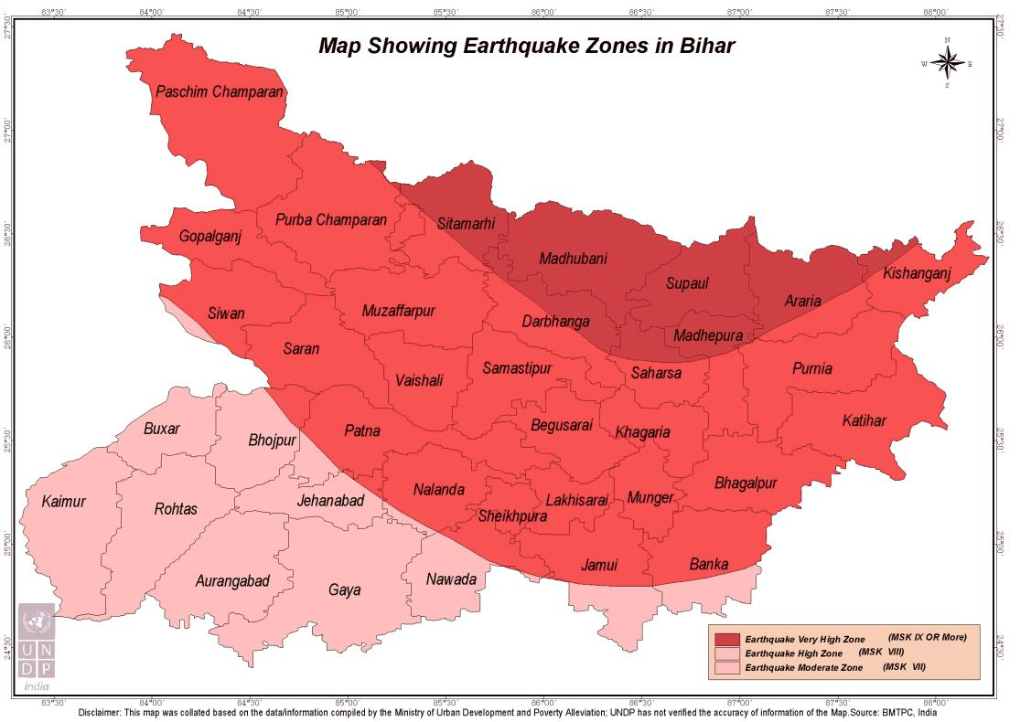

Identifying current and potential risks
On the basis of secondary data available the risk assessment of the districts has been done. These past data shows that there is are chances of multi hazard threats in the given 4 districts. The below table shows the basic profile of the 4 districts.
District | Sub Divisions | Block | Panchayat | Villages | Population | Male | Female
Gopalganj | 2 | 14 | 234 | 1566 | 2,558,037 | 1,269,677 | 1,288,360
Figures as per census 2011

Hazard Profile of the Districts
District | Wind & Cyclone Zone | Earthquake Zone | Flood
GOPALGANJ | High Damage Risk Zone (Vb = 47m/s) | IV  (High Damage Risk Zone) | FLZ  Flood Zone / Area liable to Flood

The below mention maps are from the district administration website.
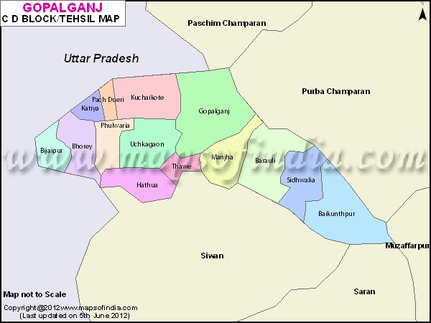
Flood hazard Maps
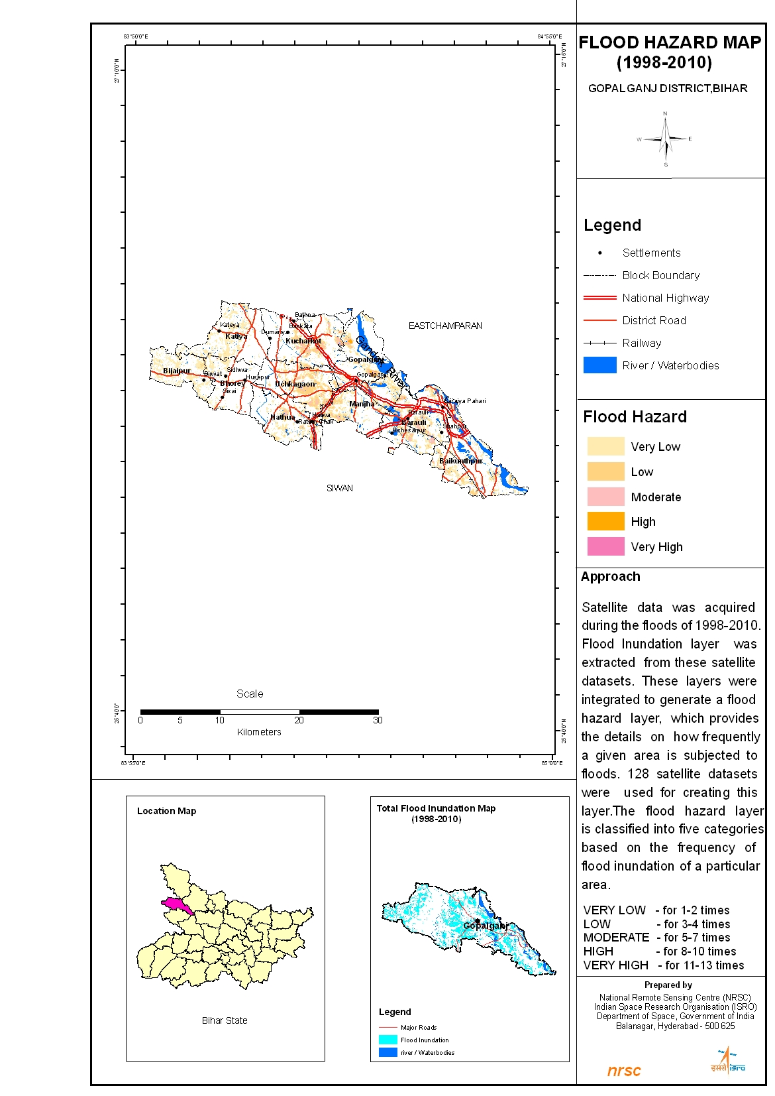

Action Oriented Plan
Preparation of plans: All districts will have DDMPs and all constituents (administration, CBOs, CSOs and PRIs) are aware of such plans and their roles and responsibilities.
Dynamic plans: Districts will have improved formats for DDMP to capture hazard and risk assessment risk analysis and reduction plan (development and contingency plan) and monitoring of the plan.
Convergence and correlation: All line departments prepare their own sectoral plan and contribute to the DDMP and DDMP will be part of CDP.
HVCA: District prepares DDMP having Hazard, Vulnerability and Capacity Assessments (HVCA) which lead to comprehensive contingency and risk reduction plan.
Sustainability: Commitment from state and district authorities to adopt the process and methodologies for DDMPs.

Scope of the Project

Approach for Comprehensive Plan
The approach towards the entire exercise would include secondary data collection, stakeholder mapping, survey tool development including development of questionnaire, checklist and draft template, training of local survey teams, primary data collection and use of GIS for hazard mapping, resource mapping and vulnerability mapping.
District level consultation will be organised in each proposed project district during the project to revise the outline to make the DDMP Inclusive. This will be mainly with District, Disaster Management Authority (DDMA) and other line departments, PRIs, municipalities/ municipal corporations, grassroots organisations/CBOs and communities. This will be facilitated by Caritas India along with DDMA of the respective districts.
The outputs will be the district level Advisory Committee of each district and detail timeline from district authorities to adopt the process and methodologies of Multi hazard DDMP.

Consideration for lower administrative units below district – Block & Panchayat level interventions
Each Panchayat and Block will be involved in the DDMP planning process. There will be a consultation at district level for all these lower administrative units below districts. In these consultation the participants will be provided with a simple data collection formats for collecting data in terms of Hazard Vulnerability and Capacity of their respective Panchayats. They will be trained in collecting data in a participatory way involving their local community.

Mainstreaming DRR & CCA to be taken into consideration
The mainstreaming of DRR and CCA will be done with the help of local community. The DRR basically will be reflected in preparedness plan of the districts. For e.g. the annual plan updating is one of the best example of the DRR. This will be a big achievement that the entire district level stakeholders at their own level seriously review their plan and make necessary preparedness before the any disaster occurs. So during the planning exercise each line department will participate in the consultation and share how and what DRR measures their respective department will adopt so that the loss in case of any disaster is reduced.
In the similar line the Climate Change adaptation will also be introduced in the DDMP. The community and the respective departments will be oriented on the CCA details and how they can make use of it in there planning exercise.

Value addition by agencies
Caritas India will introduce the innovations in each of the DDMP based on the local context. We have a first-hand experience of making of DDMP in Madhubani, so we will avoid all the shortcomings happened in Madhubani in our 4 districts. Caritas India is also State Training agency under Gov. of Bihar under NRHM program, so we will highlight the health issues in the DDMP and address the health issues during disasters. Caritas India in Bihar is working with most marginalized musahar communities. We shall try to bring their voice and address their issues during disaster through this inclusive DDMP. Caritas India has a long working experience in Bihar and at present working with 10 NGO partners in Bihar, their grass root level expertise will be used in this DDMP making process.

Districts’ Profile

Multi-hazard focus - including vulnerabilities in terms of socio-economic details and also the capacities existing in the districts
Gopalganj District comes into existence on 2nd October’1973. Earlier it was a part of old Saran District and has closed linked with the history of parent’s district. Earlier it was a Sub – Division of Saran District.
The District of Gopalganj is located on the West –North corner of the Bihar State. Between 83.54° - 85.56° latitude and 26.12° - 26.39°North Attitude. It is bounded on East by Champaran and river Gandak on the South by Siwan District and on the North West Deoria District of Uttar Pradesh. The river Gandak supported by tributaries like Jharahi, Khanwa, Daha, Dhanahietc give a big status of river. Due to this land of District is fertile and alluvial because of this river the District is good in cultivation and irrigation. The river imparts prosperity to the people to play and important role in making the District significant and unique. River Gandak by depositing the top quality of soil bringing from the Nepal, place and important role in the economy of the District.
Historians establish on the basis of analysis of evidences that this place was underthe king of Videh during Vaidic age. During the Aryan period a schedule tribe Vaman King Cheroroled the place. The rulers of that time were found of making temple and other religious supports. It is one of the reasons that there are so many temples and others religious places are within the reason. Some significant temples and religious supports within the district are Durga’s temple of Thawe, fort of Manjha, VamanGandey Pond of DighwaDubauli, Fort of King Malkhan of Sirisia, Kuchaykot etc.
People of Gopalganj where always in the lime light either it be thestruggle for freedom. Including J. P. movement and movements for women education and movement against non payment of tax and prohibition of 1930. Under the leadership of Babu Ganga Vishnu Rai and Babu Sunder Lal of Bankatta. In 1935 Pandit Bhopal Pandey gave his life for the freedom of the country.

People of Gopalganj are indebted to the freedom fighters to who gave there lives for motherland. During Mahabharat age this region was under the King BhuriSarwa. During 13th Century and 16th Century the place was ruled by Sultan of Bengal Gayasuddin Abbas and Babar.

DisasterRisk and Vulnerability Profile
The physical (geographical) area of the Gopalganj District approximates about 2033 sqr. Km. Total physical area can roughly be put in two categories i.e. Normal Area and Lowly Area (food infected area) parts of the six blocks like Gopalganj, Kuchaykot, Manjha, Sidhwalia, Barauli and Baikunthpur are flood affected areas.
These areas remain under water in the rainy season. But so far as cultivation and agriculture is concern these areas called stock of food grains. Rest of the parts is normal area with full greenery and cultivable land.
Climate of Gopalganj is the same as rest of Bihar and can be demarcated a normal climate.Summer season – March to June. Rainy Season - July to October.Winter Season - November to February.Spring Season - February to March.Gopalganj falls within the zone of normal temperature. Normally temperature of the district varies between 10°c. - 30°c. in Winter and 30°c. - 40°c. in Summer.Gopalganj is situated in the region of good rain fall. Manson touches the district normally in the second half of June and showers the district up to September. Good rain falls are the main reason for development of agriculture and vegetation. The average rain fall in the district is 1009 mm.Soil found in the district mainly Clay Soil, Sandy Soil and Alluvial Soil GangaticSoil.For agriculture and vegetation. This type of Soil is useful and important.Animals widely found in the district are Cows, Buffaloes, Horses, Sheep, Goats and Pigs. These animals play an important role in the life of farmers. Some small wild animals like Nil Gay, Rabbits, Sahil, Jackals, Fox and Peacock are in the area within the district. Some times Deers, Elephants and Leopards and also seen within the district.Gopalganj falls under greenbelt areas. Roughly all types of trees and plants are found in the district namely Babbul, Neem, Shisham, Mango, Sagwan, Katahal, Sal, Shakhuwa, Peepal, Bargad etc.
Unfortunately the people of Gopalganj due to lake of awareness are cutting trees without carrying for its bad impacts. Awareness about the ecological balance must be spread amount the general people specially the children.
The District is suffering from major two setbacks. 1 – Flood. Time and again the district faces flood form river Gandak that destroy standing Crops and human lives and cattle lives. Half of the blocks face flood during the rainy season. Partly or wholly. This cause threat to the recourses of the district. All though there is a JamindariBandh and protective Ring Bandh on the bank of river Gandak but the condition of the Bandh is worst the District has to face a lot of problem to protect the Bandh. These Bandhs are repaired time and again.

Approach, Methodology and Activities

Data Sources – Primary & Secondary (including relevant maps)
- Meeting with District Magistrate, Line Department officials, Bihar Inter Agency Group to know their perspective on DDMPs. The existing data in the district will will be collected from the different line department of the respective districts. The NIC of the respective districts will be involved in the data compilation.
- Meetings with PRI members and local NGOs to know the local issues and risks which is occurring in the districts. The Participatory risk assessment exercise in details will be planned with the help of local Panchayats.
- Secondary data from various sources for Hazard, Vulnerability and Capacity Analysis. The data will be collected from all the source available in the districts such as line department, university and also from different NGOs.
- Once we complete the data collection and compilation, a team will do the data analysis. On the basis of this data analysis a detail HVCA report will be prepared which will be shared with different stakeholders. A series of consultations with line departments, PRIs and Communities and Local NGOs done in order to review a draft HVCA report of the district
- Sample Data from Gram Panchayat to be collected by the personnel. By involving the volunteers available in the district like Nehru Yuva Kendra, NGO Volunteers etc. sample data collection at Panchayat level will be done. The prime objective of this data collection will be to bring the people’s voice in the DDMP and which will make it more inclusive.
- 2 % of total Gram Panchayat to be checked and verified

Stakeholders’ involvement (including IDRN)
Sr. No. | Name of Partner Agency | Role
1 | Caritas India | Facilitating Agency (Lead Agency)  - Coordinate the entire initiative  - Engaging with BSDMA and DDMA  - Coordinate with all the partners of BSDMA  - Coordinate with state and district governments  - Jointly organise district level consultation with respect DDMA and state authority in each district  - Prepare training module  - Conduct ToTs
4 | SDMAs | - State Level Guidance and Approvals  - Facilitate district authorities  - Presence and guidance during state consultation
5 | DDMAs | - District Level Guidance and Approvals  - Line department coordination  - Communication  - Logistic arrangement  - Coordination with panchayats  - Support and linkage to Flagship schemes  - Commitment to link DRR with Panchayat plans
6 | PRIs and municipalities/ municipal corporation and Grassroot Organisations | - Grass root level support and guidance to design outline of DDMP  - Commitment to capture voices of vulnerable groups in DDMP  - Coordinate with government agencies and get the plans of district consultations implemented
7 | Bihar Inter Agency Group (BIAG) | - Coordinate with BSDMA and Department of Disaster Management;  - Coordinate with other agencies doing DDMP in other districts of Bihar;  - Guidance to organise consultations on HVCA and DDMP Framework

DDMP Preparation Planning & and Reporting Mechanism

Ensuring involvement and ownership of DDMAs
District level consultation will be organised in each proposed project district during the second month of the project to revise the outline to make the DDMP Inclusive. This will be mainly with District, Disaster Management Authority and other line departments, PRIs, municipalities/ municipal corporations, grassroots organisations/CBOs and communities. This will be facilitated by Caritas India and other respective local NGOs of the local area. The outputs will be the district level Advisory Committee of each district and commitment from district authorities to adopt the process and methodologies of DDMP. In each and every steps the DDMA will be involved so that they are aware about the entire process. The agency will also orient the entire district team so that the DDMA take lead from following year to update the DDMP if required.

Timeline and Delivery Schedule (Table)
 | Activity | Activity Description | Output | Timeline
1. | Meeting with Different stake holders | Meeting with District Magistrate, Line Department officials, Bihar Inter Agency Group to know their perspective on DDMPs | Stakeholders would know the process and agreed to do work together | 1st Month
2. | Meeting with PRIs and other NGOs | Meetings with PRI members and local NGOs to know the local issues and risks which is occurring in the districts | PRIs and other NGOs have their common understanding and extend their arm for DDMPs | 1st Month
3. | Collection of secondary data for Hazard, Vulnerability, Capacity Analysis | Secondary data from various sources for Hazard, Vulnerability and Capacity Analysis | Mapping the different kind of disaster occurred in areas. | 2nd Month
4. | Consultation for HVCA report | A series of consultations with line departments, PRIs and Communities and Local NGOs done in order to review a draft HVCA report of the district | To know how disaster which was happen and do all the vulnerability is mapped correctly | 2nd Month
5. | Sample Data Collection | Sample Data from Gram Panchayat to be collected by the personnel | To have firsthand data for making the plan | 3rd Month
6. | Verification of data | 2 % of total Gram Panchayat to be checked and verified | Data checked and verified | 3rd Month
7. | Consolidation of Data | The data coming from villages will be punched in excel | Digitalization of all data into soft. | 4th Month
8. | Analysis of Data | The consolidated data will be analyzed. | Draft report of DDMP will be prepared | 4th Month
9. | Draft report presentation | The draft report will be developed and it will be presented in fronts of district officials and Line departments | Feedback on the draft report will be taken and suggestion will be incorporated. | 5th Month
10. | Draft report to be send to BSDMA | The draft report after taking feedback from district official with correction it will send to BSDMA for approval | Finalization of DDMP | 5th Month
11. | Finalization of DDMP | Finalization of DDMP plan after getting some of feedback from BSDMA | DDMP got approval from concerned District | 6th Month
12. | Submission of Final Plan | Final Plan will be submitted to District and as well as BSDMA for approval. | DDMP plan finalized and submitted to concerned Authority | 6th Month
Threat : Assembly Election may hinder to collect data and organize workshop, interview with Government officials

Monitoring and Evaluation System
The project team involved in the making of DDMP in all respective districts are DRR expertise. We will engaged external consultants for the periodic monitoring of the DDMP making process. The District Administration (DDMA) is the prime responsible for the making of DDMP. We shall coordinate with the respective districts point person nominated by DDMA and SDMA to move the work forward.
- Line of internal accountability/reporting: District Coordinators will be reporting to the DDMA and Caritas India Team Leader each week and the Team leader will report to the BSDMA and Caritas India Director about progress and future action plan.
- Data collection, compilation and analysis and decision making processes and tools: Caritas India Team Leader along with DDMA will develop tools for data collection and analysis with the support from BSDMA Resource Person.
- Frequency of reviews/decision making meetings: For project monitoring and reporting a monthly meeting of all team members is decided at organization headquarter or sometimes in the districts. The BSDMA resource person will also be participating in the monthly review meeting.
- Reporting to internal stakeholders and to BSDMA: Monthly progress report will be sent to BSDMA along with action plan of next month.
- Feedback: The District Coordinator will take regular feedback from DDMA and will share the same with the team leader. Also feedback will be taken from resource persons BSDMA and other visitors to the project area.
- Documentation: The reports from the field will be documented by the district Coordinators. The team Leader will be responsible for the consolidation of report and sharing it with BSDMA.

Project Team

Team Leaders and other Team Members – CV (Qualifications and Experience), Roles and Responsibilities etc.
S.No. | Name of Personnel | Area of expertise | Designation & Organization | Year of Experience
1. | Girish Peter | Community Mobilization, Disaster Management, Human Rights | Team Leader | 12
2. | Chandan | Livelihood and participatory planning | District Coordinator (Buxar) | 5
3. | Abhishek Kumar | Community mobilization and Liasoning with Government | District Coordinator (Siwan) | 7
4. | PoojaRana | Community mobilization and Disaster Management | District Coordinator (Saran) | 4
5. | Saurabh Kumar | Community mobilization and Disaster Management | District Coordinator (Gopalganj) | 3
6. | Anjan Bag | DRR planning and Risk Mitigation | Technical Support | 15
7. | Munish Kaushik | Project Management, DRR and Advocacy | Technical Support | 14
8. | Babita Alick | Mass Communication, Disaster Management | Technical Support | 16

